**The PN Junction. How Diodes Work?**

We can find semiconductor PN junctions in many places. They form part of electronic and optoelectronic devices such as solar cells that transform solar energy into electrical energy; light emitting diodes, known as LEDs; rectifier diodes and transistors.

To understand what semiconductor materials are and how PN junctions are fabricated, we need to dive into the atomic world.

Currently, the most well-known semiconductor is silicon.

In a silicon crystal, each atom is bonded to its neighbours by four electrons forming covalent bonds.

At low temperatures, these electrons remain in the covalent-bonds. When the temperature rises, some of the electrons in the bonds are able to gain thermal energy and escape.They are now free to move and to conduct electricity. At the same time, the broken bonds can be occupied by electrons from other bonds. For these electrons to move, no additional energy is required on average. This broken-bond or new state is termed hole and behaves as a particle of positive charge.

Impurities can be introduced into the semiconductor, substituting atoms of a different atomic species for the silicon atoms. If the new atom has five electrons in its outer shell, four of them will replace the four electron-bonds of silicon. The extra electron will be loosely bound to the impurity. At room temperature, this fifth electron is liberated from its original atom, becoming a conduction electron. Consequently, the impurity acquires a positive charge. This may result in the number of electrons in the doped material exceeding the number present in a pure semiconductor. The number of implanted impurities can be controlled using the fabrication technology. A semiconductor containing these impurities is called an N-semiconductor, since it has negative charge carriers. The impurities are named "donor" impurities, since they donate electrons.

An impurity with only three electrons in its outer shell can also be used. The three outer electrons complete three of the four bonds. The fourth bond remains unoccupied. However, at room temperature the electrons from other bonds can move in to occupy this free space, creating a hole in the material and a negatively charged impurity. As in the previous case, the number of implanted impurities can be controlled using the fabrication technology. So, the number of holes in this doped material can be much greater than the number of holes in a pure semiconductor. A semiconductor of this type is called a P-semiconductor, because it has positive charge carriers, and these impurities are named “acceptor” impurities, since they accept an electron.

Exercise: Try to define these concepts:

Covalent bond = ..........................................................................................................

......................................................................................................................................

Donor =.........................................................................................................................

......................................................................................................................................

Hole =...........................................................................................................................

......................................................................................................................................

Acceptor =....................................................................................................................

......................................................................................................................................

**PN Junction**

A PN junction is a structure formed by neighbouring regions with different dopings, p-type and n-type semiconductors. The PN junction is a crucial part of many devices, such as, for example, the diode.

If a positive voltage drop is applied between the p terminal and the n terminal of a diode, a large current can be observed experimentally. If we change the connectors and a positive voltage drop is applied between the n terminal and the p terminal, an extremely small current, negligible for most practical applications, is observed experimentally.

The PN junction shows this asymmetric behaviour. The current can flow in one direction but not in the other. This is a peculiar behaviour, which enables a wide spectrum of applications in circuits.

To understand this particular feature of the PN junction, we must consider two mechanisms that create an electric current: the diffusion mechanism and the drift mechanism.

One way to understand the diffusion mechanism is to imagine two sets of different-coloured particles concentrated in two distinct zones. If the particles are free to move in different directions, their random motion tends to equalise their concentration in the whole volume. Diffusion is the physical mechanism which gives rise to free particles trying to occupy the maximum possible volume.

The drift mechanism is a movement caused by an electric field. This electric field makes the positive charge carriers move in one direction, and the negative charge carriers in the other. If there is an electric field in a region of space, there will be an electric potential associated with it. The electric field points in the direction in which the electric potential decreases.The varying electric potential acts as a barrier, preventing the charge movement.

Its effects can be understood with the following analogy: let us consider a body moving at a certain speed in the gravitational field. If the body rises, it loses kinetic energy and gains potential energy. If the initial kinetic energy is not sufficient, the body will be unable to cross the barrier, but in the event that the initial kinetic energy is enough, the body may be able to surmount it and even have sufficient kinetic energy left to enable it to continue its movement.

Similarly, the electric potential behaves like a barrier to the charged particles: it allows the particles to surmount it, whenever the kinetic energy is great enough.

**Exercise**: Try to define these mechanisms:

Diffusion motion= .........................................................................................................

......................................................................................................................................

Drift motion=.................................................................................................................

......................................................................................................................................

Reproduce these designs, orienting them in the correct way so that they are tree symbolic representations of the same device.

.......................................

.......................................

.......................................

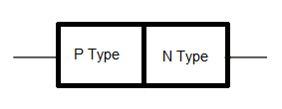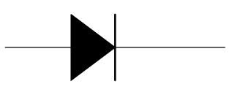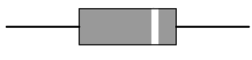

**Didactic model and working of a PN junction**

The process of fabricating a PN junction begins with an n-type or p-type doped semiconductor into which the opposite type of impurity is introduced. To understand how this structure works and what physical processes take place in it, a didactic model is used. The model consists of a P semiconductor perfectly matched to an N semiconductor. The P semiconductor has a much higher hole concentration than the N semiconductor. Therefore, holes from the P region will diffuse into the N region. Similarly, electrons from the N will diffuse into the P region.

The diffusion of electrons and holes creates a region depleted of free charge particles, leaving behind the ionised impurities from which these charge particles come. Thus, a region of positive ionised impurities and a region of negative ionised impurities appear in the PN junction. This special distribution of charges creates an electric field.

**Exercise:** Label with the correct terms.

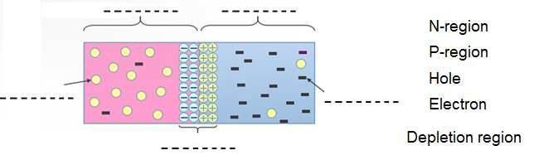

The electric potential associated with this field acts as a barrier that prevents the displacement of the electrons and holes. Equilibrium is reached when the diffusion current equals the drift current.

The potential barrier is an obstacle for the diffusion current in the device. It is possible to reduce the height of this potential barrier by the application of an external voltage.

This increases the electric current. By applying an external voltage from a battery, the height of the potential barrier in the junction is modified. If a positive voltage drop is applied between the P and N regions, the barrier height is reduced. A reduced barrier cannot prevent electrons and holes from diffusing across the structure. An electric current appears in the junction due to the diffusion mechanism. Under these conditions, the PN junction is said to operate under forward bias.

If the voltage is reversed, and becomes greater in the N than the P region, the barrier height increases, preventing the electron and hole diffusion. The electric current is then negligible.

In conclusion, the PN junction can only conduct in a single direction, giving rise to a current which increases very rapidly when the potential barrier is significantly lowered.

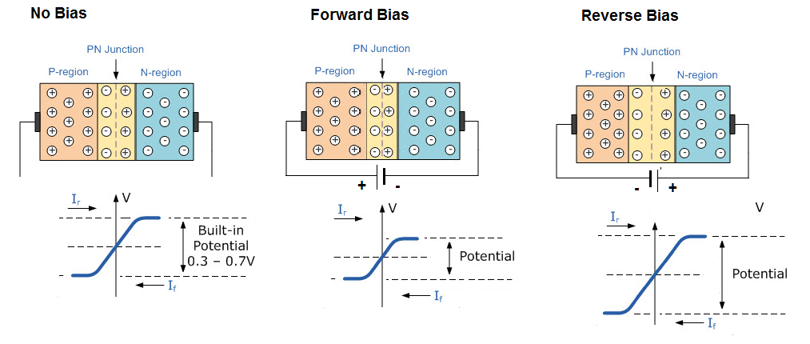

**Optoelectronic applications: the LED**

Besides being present in countless circuits and electronic components, PN junctions can also be found in optoelectronic applications: in devices such as LEDs, photodiodes and solar cells.

The origin of the light emitted from a LED can be found in the physical phenomenon of recombination. Recombination is a process where an electron and a hole are annihilated, releasing energy. In the case of certain materials, and under forward bias, this energy is emitted as light. The more electron-hole pairs recombine, the more intense this light is.

The operation of the photodiodes and solar cells is based on the opposite physical phenomenon: generation. Thus, a photon can create an electron-hole pair, which by its movement can generate an electric current.

To summarise, PN junctions are ubiquitous in our environment, close and distant. It seems unbelievable that such a simple device is so useful and affects so much in our lives.

**Exercise:**



**Exercise:**

This graph describes diode behaviour.

Try to explain the meaning of each part of it.

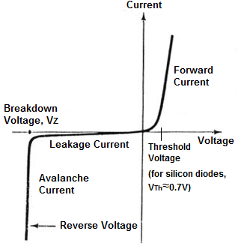

Following questions can help your analysis:

- Which "Voltage" is considered on the X axes?

- Which "Current" is considered on the Y axes?

- What could be the "Threshold Voltage"?

- What happens when the "Breakdown Voltage" is reached?